ALGORITHM-BASED RUBIK’S CUBE SOLVER

A PROJECT REPORT

Submitted by

AKSHAYA NANTHINI V S | 210121104006

in partial fulfilment for the award of the degree

of

BACHELOR OF ENGINEERING

IN

COMPUTER SCIENCE AND ENGINEERING



ALPHA COLLEGE OF ENGINEERING ANNA UNIVERSITY: CHENNAI 600 025
MAY 2025



ANNA UNIVERSITY: CHENNAI 600 025

BONAFIDE CERTIFICATE

Certified that this project report “ALGORITHM-BASED RUBIK’S CUBE SOLVER” is the bonafide work of “AKSHAYA NANTHINI V S (210121104006)” who carried out the project work under my supervision.

SIGNATURE SIGNATURE

Dr. T. Jerry Alexander, M.E., Ph.D., Ms.Deepa A, M.E.,
HEAD OF THE DEPARTMENT SUPERVISOR
Department of Computer Science Department of Computer Science and Engineering, and Engineering,
Alpha College of Engineering, Alpha College of Engineering, Thirumazhisai-600 124. Thirumazhisai-600 124.
This project work was submitted for viva voce held on at Alpha College of Engineering.
Subject Code: CS3811

INTERNAL EXAMINER EXTERNAL EXAMINER

ACKNOWLEDGEMENT

All praise and glory to GOD Almighty who has showered us his heavenly Knowledge and wisdom to complete our project work successfully.

We wish to express our heartfelt gratitude to our beloved Founder and Patron late SevaRatna Dr. (Mrs.) Grace George, Chairperson, Alpha Group of Institutions, for providing us this facility to study integrating with values.

We express our sincere gratitude to Mrs. Suja George, Vice Chairperson, Alpha Group of Institutions for improving the quality education constantly.

We express our sincere gratitude to Dr. B. Sowmya M.Tech., Ph.D., Principal, Alpha College of Engineering, for her motivation, encouragement and helping us to think innovatively.

We thank Dr. T. Jerry Alexander, M.E., Ph.D., Head of the Department, Department of Computer Science and Engineering, for his support and constant encouragement in all aspects of our project work.

We thank our Project Coordinator, Mr. X. Rex Arockiaraj M.E., Assistant Professor, Department of Computer Science and Engineering, for her valuable suggestions and motivation throughout our project work.

We also thank our Project Supervisor, Mrs. A Deepa, M.E., Assistant Professor, Department of Computer Science and Engineering, for mentoring and helping us immensely in all stages, henceforth leading to the completion of our project successfully.

Finally, we would thank all teaching and non-teaching staff members of our Department of Computer Science and Engineering, our parents, friends, and well-wishers who have always supported us in all our work.

ABSTRACT

The Rubik’s Cube is a three-dimensional combinatorial puzzle composed of a pivot mechanism that enables independent rotation of each face, resulting in a wide array of scrambled configurations. The objective is to return the cube to its original state, where each face displays a uniform color. While optimal solutions require a maximum of 20 moves, existing high-speed Lego-based robotic solvers complete the task in approximately 1 second, whereas top human solvers average around 5 seconds.
This project introduces an optimization approach to further reduce the solving time of robotic systems without decreasing the number of required moves. The proposed method emphasizes parallel execution of independent moves, thereby decreasing total solve time by exploiting mechanical capabilities rather than purely algorithmic improvements. Specifically, the study incorporates the rob-twophase algorithm, which is designed for axial robot architectures that allow simultaneous movement of opposite faces. By aligning the solution strategy with the physical characteristics of such robots, this parallelization technique significantly enhances the efficiency and speed of the solving process.

 | TABLE OF CONTENTS
CHAPTER | TITLE |  |  |  | PAGE NO
 | ABSTRACT |  |  |  | iii
 | LIST OF FIGURES |  |  |  | viii
 | LIST OF TABLES |  |  |  | Vii
1 | INTRODUCTION |  |  |  | 1
 | - Rubik’s Cube |  |  |  | 1
 | 1.2 Rubik’s Cube Scramble |  |  |  | 2
 | 1.3 Solving The Cube |  |  |  | 3
 | 1.3.1 Fridrich Method |  |  |  | 4
 | 1.3.2 Roux Method |  |  |  | 4
 | 1.3.3 ZZ Method |  |  |  | 4
 | 1.3.4 Beginner’s Method |  |  |  | 5
 | 1.3.5 Petrus Method  1.4 God’s Number |  |  |  | 5  6  7  8  9  9
 | 1.5 Cube Solver
 | 1.5 Python
 | 1.6 OpenCV
 | 1.7 Pycharm
2 | LITERATURE WORKS |  |  |  | 12
 | 2.1 Overview Of Rubik’s Cube And Reflection On It’s Application In Mechanism |  |  |  | 12
 | 2.2 Rubik’s Cube Solving Robot |  |  |  | 13
 | 2.3 Exploiting The Rubik’s Cube 12- Edge Pdb By Combining Partial Pattern Databases And Bloom Filter |  |  |  | 14
 | 2.4 Rubik’s Cube Solving Robot |  |  |  | 15
 | 2.5 Autonomous Rubik’s Cube Solver Using Image Processing |  |  |  | 16
3 | PROBLEM STATEMENT |  |  |  | 17
 | 3.2 Existing System |  |  |  | 17
 | 3.3 Disadvantage |  |  |  | 17
 | 3.4 Proposed System |  |  |  | 18
 | 3.5 Advantage |  |  |  | 21
 | 3.6 Requirements |  |  |  | 21
4. | HARDWARE SPECIFICATION |  |  |  | 22
 | 4.1 Webcam |  |  |  | 22
 | 4.2 Standard Rubik’s Cube |  |  |  | 22
5 | SYSTEM DESIGN |  |  |  | 24
 | 5.1 System Architecture |  |  |  | 24
 | 5.2 Use Case Diagram |  |  |  | 25
 | 5.3 Class Diagram |  |  |  | 27
6 | SYSTEM IMPLEMENTATION |  |  |  | 28
 | 6.1 Terminologies |  |  |  | 28
 | 6.1.1 Pattern Database |  |  |  | 28
 | 6.1.2 Turns And Notations |  |  |  | 29
 | 6.2 Modules |  |  |  | 30
 | 6.2.1 Image Processing and color detection |  |  |  | 30
 | 6.2.2 Finding The Solution Using Kociemba’s Algorithm |  |  |  | 31
 | 6.2.2.1 Two Phase |  |  |  | 31
 | 6.2.2.2 Domino’s Phase |  |  |  | 31
 | 6.2.3 Optimising The Solution By Marking Parellel Turns |  |  |  | 31
 | 6.2.4 Solving Cube |  |  |  | 33
7 | CONCLUSION |  |  |  | 34
 | Conclusion |  |  |  | 34
 | Future Enhancement |  |  |  | 35
 | APPENDIX 1 SAMPLE CODE |  |  |  | 36
 | APPENDIX 2 SCREENSHOT |  |  |  | 45
 | REFERENCE |  |  |  | 47

 | LIST OF TABLES
TABLE NO | TABLE NAME | PAGE NO
1.1  2.1  6.1 | Possible Configurations  List of Parallel Turns  List of turns | 9  20  30

LIST OF FIGURES

FIGURE NO | FIGURE NAME | PAGE NO
1.1 | Rubik’s Cube | 2
1.2 | Scrambled Cube | 3
2.1 | List Of Parallel Turns | 7
3.1 | Cube Solution Finder | 8
3.2 | Python | 9
3.3 | Open Cv | 10
3.2 | Pycharm | 11
4.1 | Webcam | 22
4.2 | Standard Rubik’s Cube | 23
5.1 | System Architecture | 24
5.2 | Use Case Diagram | 52
5.3 | Class Diagram | 27
6.1 | Pattern Database | 28
6.3 | Before and after solving | 33
8.1 | Before Scanning | 45
8.2 | While Scanning | 45
8.3 | After Scanning | 46
8.4 | After Finding A Solution | 46

CHAPTER 1 INTRODUCTION

1.1 RUBIK’S CUBE
The Rubik’s Cube is a three-dimensional combination puzzle invented in 1974 by Hungarian architect and professor Ernő Rubik. Originally conceived as a teaching tool to help students understand three-dimensional geometry, the cube quickly evolved into a global phenomenon. Initially referred to as the "Magic Cube," it gained widespread popularity and has since become one of the best-selling puzzles in history, with over 350 million units sold worldwide.
The standard Rubik’s Cube consists of six faces, each subdivided into 3×3 grids of smaller squares. Each face is covered with stickers of one of six colors: white, red, blue, orange, green, and yellow. The cube operates on a pivot mechanism that allows each face to rotate independently, enabling a vast number of scrambled configurations. A move involves rotating a face 90°, 180°, or 270° in either direction.
The objective is to return the cube to its solved state, where each face displays a single uniform color. Despite its seemingly simple appearance, the puzzle embodies rich logical and mathematical complexity. Solving the cube typically requires an algorithmic approach—a predefined sequence of moves designed to manipulate the cube toward its goal state. While expert solvers can complete the cube in under ten seconds, an average human solver may require 50 to 100 moves or more to reach a solution.
The Rubik’s Cube has not only served as a challenging puzzle but also as an inspiration for studies in mathematics, artificial intelligence, robotics, and mechanical engineering. In this project, the cube is explored as a platform for robotic optimization and algorithmic efficiency, focusing on techniques to reduce solving time through parallel execution strategies.

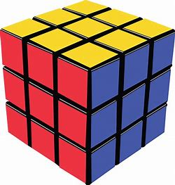

Figure 1.1 Rubik’s Cube

1.2 RUBIK’S CUBE SCRAMBLES
The Rubik’s Cube challenge begins with the puzzle in its solved state, after which it is scrambled randomly through a series of legal moves. The task is then to return the cube to its original configuration, where each face is a uniform color. Although the mechanics appear simple, the combinatorial complexity of the cube is immense.
The standard 3×3×3 Rubik’s Cube has an astonishing number of possible configurations—approximately 43 quintillion. The exact number of permutations is:
(8! * 12! * 3⁸ * 2¹²)/(2 * 3 * 2) = 4, 32, 52, 00, 32, 74, 48, 98, 56, 000

This figure arises from the various combinations and orientations of the 8 corner pieces and 12 edge pieces, subject to the mechanical constraints of the cube.
To grasp the magnitude of this number, consider this: if each permutation were represented by a single 6 cm Rubik’s Cube, there would be enough cubes to cover the surface of the Earth over 300 times. This level of complexity is what makes the Rubik’s Cube a fascinating subject of study in fields such as combinatorics, algorithm design, and robotics.
Efficiently solving such a vast number of potential states requires the use of smart algorithms and strategic move sequences, particularly when developing robotic systems designed to solve the cube in minimal time.
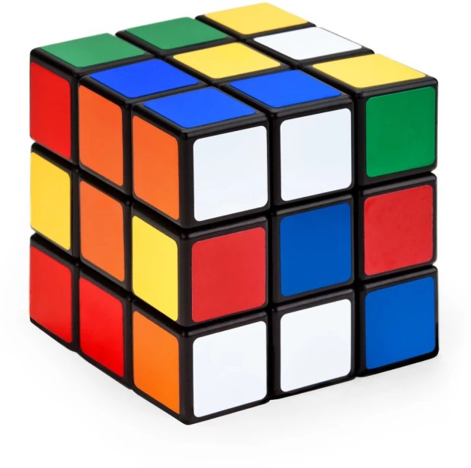
Figure 1.2 Scrambled Cube

1.3 SOLVING THE CUBE

The Rubik’s Cube can be solved using a variety of algorithms, many of which have been developed by mathematicians, speedcubers, and computer scientists over the years. These solving methods are fundamentally based on graph theory, where each configuration represents a node in a vast state space, and each legal move is an edge connecting states.
Solving the Rubik’s Cube involves moving from a scrambled state to the solved state through a sequence of defined moves (algorithms). Several popular solving methods exist, each with different approaches in terms of efficiency, memorization, and number of moves.
Common Solving Methods:
- Fridrich Method (CFOP)
- Roux Method
- ZZ Method
- Beginner's Method
- Petrus Method

1.3.1 FRIDRICH METHOD (CFOP)

The Fridrich Method, widely used by speedcubers, is also known as CFOP, an acronym for:
- Cross
- First Two Layers (F2L)
- Orient Last Layer (OLL)
- Permute Last Layer (PLL)
Steps involved:
- Form a white cross on one face.
- Solve the corners of the white face and the second layer (F2L).
- Use OLL algorithms to orient all last-layer pieces (typically yellow).
- Use PLL algorithms to permute the last-layer pieces and complete the cube.
This method balances speed and efficiency and is the most commonly used method in competitions.

1.3.2 ROUX METHOD

The Roux Method involves building two 1×2×3 blocks on opposite sides of the cube. The remaining steps involve manipulating the middle layer and the last layer using fewer rotations of the cube. While innovative, this method is less popular among speedcubers due to its learning curve and slightly lower average efficiency in competitive settings.

1.3.3 ZZ Method
The ZZ Method solves the cube in three major stages:
- Edge Orientation (EO) Line – all edges are oriented to allow efficient moves.
- First Two Layers (F2L) – solve the bottom two layers.
- Last Layer (LL) – orient and permute the final layer.
While theoretically elegant, the ZZ method requires more moves and is less efficient than CFOP in most speedcubing applications.

1.3.4 BEGINNER’S METHOD
The Beginner’s Method is typically the first solving approach learned by newcomers. It uses a straightforward layer-by-layer strategy:
- Form the white cross.
- Solve white corners.
- Solve the second layer edges.
- Create a yellow cross.
- Position yellow edges.
- Position yellow corners.
- Orient yellow corners to complete the cube.
Though not optimized for speed, it is easy to understand and provides a foundation for learning advanced methods.

1.3.5 PETRUS METHOD
The Petrus Method, developed by Lars Petrus, follows a block-building approach with a focus on reducing unnecessary moves. Steps include:
- Build a 2×2×2 block.
- Expand to a 2×2×3 block.
- Orient the remaining edges.
- Complete the First Two Layers (F2L) with minimal face turns.
- Permute the last-layer corners.
- Orient the last-layer corners.
- Permute the last-layer edges to complete the cube.
This method is flexible and efficient but less used in competitive speed cubing.
1.4 God’s Number
Every position of a standard 3×3×3 Rubik’s Cube can be solved in 20 moves or fewer using the most optimal algorithm. This minimum upper bound of 20 is known as God’s Number.

Using approximately 35 CPU-years of donated computing time from Google, a team of researchers in 2010 conclusively proved that no configuration of the Rubik’s Cube requires more than 20 moves to solve, under the half-turn metric (where a 180° turn counts as one move).

This theoretical perfect solution path is referred to as God’s Algorithm—the algorithm that always solves the cube in the fewest possible moves. While most human-solvable algorithms require 40 to 60 moves, God's Algorithm would always solve the cube in optimal efficiency.

The Rubik’s Cube has over 43 quintillion possible configurations:
43,252,003,274,489,856,00043,252,003,274,489,856,00043,252,003,274,489,856,000 .

Each configuration can be categorized by the minimum number of moves required to return to the solved state. The discovery of God’s Number marks a significant milestone in computational mathematics, demonstrating the perfect limit of solving efficiency for one of the world’s most iconic puzzles.
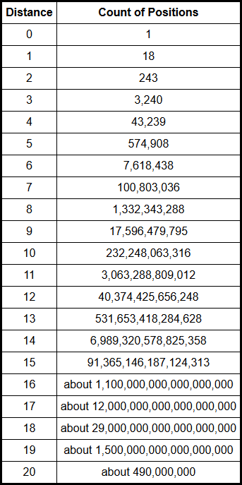
Table 1.1 Possible Configurations

1.5 Cube Solver
The cube-solving software is developed in Python using OpenCV and runs on a Linux platform. A webcam captures images of the six faces of the scrambled Rubik’s Cube. The software analyzes the colors and reconstructs the cube’s current state.
Once the cube's configuration is determined, the software applies Kociemba’s two-phase algorithm to generate an optimized solution string. This string represents the sequence of moves required to solve the cube and is designed to contain no more than 20 moves in most cases.
The resulting move sequence is formatted as a string and can be transmitted to a microcontroller or robotic system for execution. While our current implementation focuses on the software side, the output is compatible with systems that include servo motors or mechanical solvers.
An illustration of the software interface is provided in Figure 3.1.
Figure 1.2 Cube Solution Finder
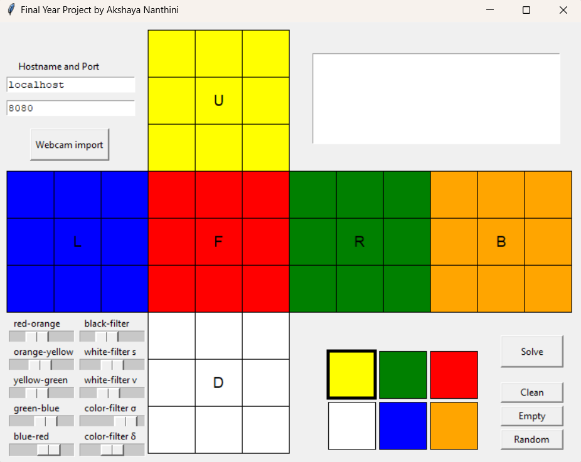

1.6 Python
Python is an open-source, high-level programming language known for its readability, simplicity, and versatility. It is an interpreted language, which allows developers to run and test code quickly without the need for compilation—making it ideal for rapid development and prototyping.
Python’s clean and readable syntax, which uses indentation instead of braces, makes it especially suitable for beginners and efficient for experienced developers. Although slower than compiled languages like C, Python offers faster development time and supports integration with other languages when performance is critical.
It is widely used in various domains including:
• Web development
• Scientific and data analysis
• Desktop applications
• Network programming
Python also benefits from a vast ecosystem of libraries and tools, which enhance its functionality and make it a powerful choice for both simple scripts and complex applications.

Figure 1.3 Python

1.7 OpenCV
OpenCV (Open Source Computer Vision Library) is an open-source computer vision and machine learning library designed to support real-time vision applications. It provides a robust infrastructure for image and video processing, making it widely used in both academic and commercial projects.
With over 2,500 optimized algorithms, OpenCV supports tasks such as face detection, object recognition, motion tracking, 3D reconstruction, and more. It is compatible with C++, Python, Java, and MATLAB, and supports multiple platforms including Windows, Linux, macOS, and Android.
In our project, OpenCV is used for color detection and image analysis to read the six faces of the Rubik’s Cube accurately. Its real-time processing capabilities and extensive library functions make it ideal for such computer vision tasks.
OpenCV is widely adopted by leading companies like Google, Microsoft, Intel, and numerous startups, due to its performance, flexibility, and open-source licensing.

Figure 1.4 OpenCV


1.8 PyCharm
PyCharm is a powerful Integrated Development Environment (IDE) developed by JetBrains, specifically designed for Python programming. It offers a user-friendly interface, intelligent code assistance, and advanced debugging tools that make it ideal for both beginners and experienced developers.
PyCharm supports key features such as:
- Syntax highlighting and code completion
- Real-time error detection and code suggestions
- Integrated version control (Git, SVN)
- Built-in terminal and Python console
- Seamless integration with libraries like OpenCV, NumPy, and TensorFlow
In our project, PyCharm is used as the primary development environment for writing and testing Python code, including the implementation of Kociemba’s Algorithm and OpenCV-based image processing. Its structured layout and efficient tools enhance productivity and simplify debugging during development.
It’s both Community (free) and Professional (paid) editions, and supports platforms like Windows, Linux, and macOS.

Figure 1.5 PyCharm

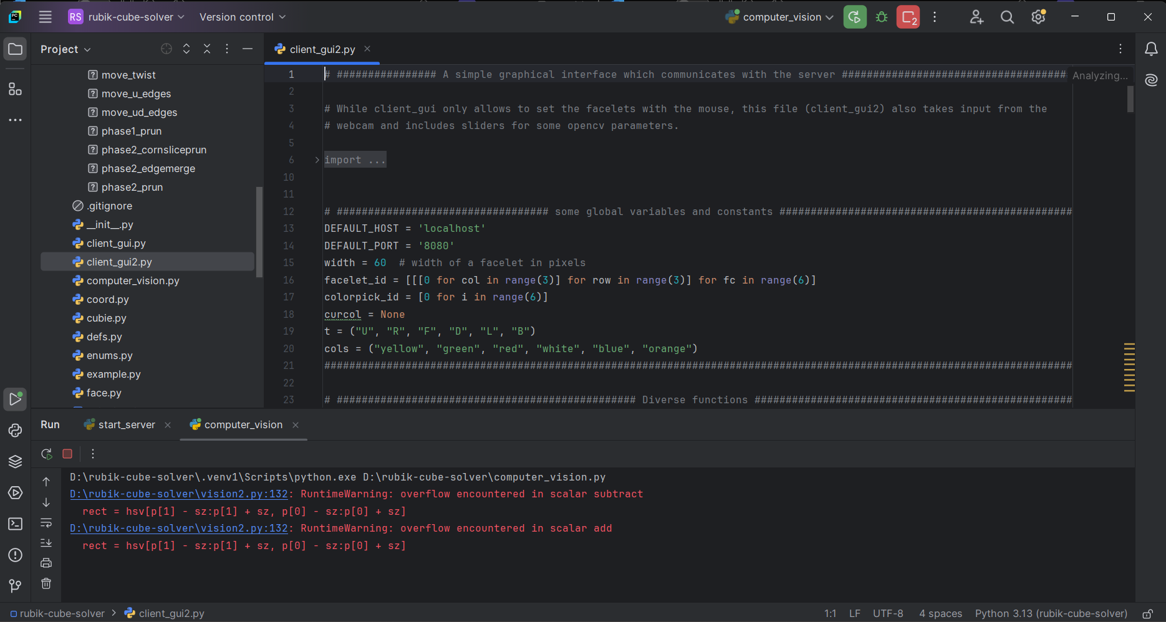

CHAPTER 2:
LITERATURE WORKS
2.1 Literature Survey

Title 1:
Overview of Rubik’s Cube and Reflections on Its Application in Mechanism
Authors:
Da-Xing Zeng, Ming Li, Juan-Juan Wang, Yu-Lei Hou, Wen-Juan Lu, and Zhen Huang
Description:
This research paper offers a comprehensive overview of the Rubik’s Cube, highlighting its origins, evolution, and its significance as a mechanical art form. The authors explore the cube from several dimensions: its invention, structural characteristics, interdisciplinary research, and mechanical design principles. Special attention is given to its applications in mechanical engineering and the potential future role of the cube in mechanism design and innovation. Additionally, the paper reviews global research contributions, including metaphorical interpretations, solving algorithms, functional applications, and structural mechanisms of various cube types.
Merits:
- Provides an in-depth explanation of the cube’s internal mechanical structure.
- Discusses the structural core present in different types of Rubik’s Cubes.
- Interdisciplinary research in engineering, mathematics, and education.
Demerits:
- Does not address the concept of optimal solutions or minimal-move solving algorithms (e.g., God's Algorithm).
- Focus is more on mechanical and design aspects
Title 2:
Rubik’s Cube Solving Robot
Authors:
Jacob Swiezy, Nathaniel Knopf
Description:
This paper presents the development of a Rubik’s Cube solving robot designed using an FPGA (Field-Programmable Gate Array) interface. The system integrates two RGB color sensors to sequentially scan the stickers of a scrambled Rubik’s Cube. The raw sensor data is then processed to construct a digital representation of the cube’s current configuration. An embedded algorithm receives this representation and computes an optimized sequence of moves required to solve the cube. These instructions are translated into motor control signals for six stepper motors, each responsible for rotating a specific face of the cube. The stepper motors, driven via motor drivers connected to the FPGA, perform the movements to physically solve the puzzle.

Merits:
- FPGA enables high-speed control of stepper motors, contributing to efficient face rotations.
- Integration of hardware and algorithm provides a fully automated solving solution.
Demerits:
- The cube reading process is relatively slow due to inefficient image processing.
- Sensor-based scanning method increases the time before solving begins.

Title 3:
Exploiting the Rubik’s Cube 12-edge PDB by Combining Partial Pattern Databases and Bloom Filters
Authors:
Nathan R. Sturtevant, Ariel Felner
Description:
This paper addresses the challenge of compressing and utilizing the massive 457 GB 12-edge Pattern Database (PDB) for Rubik’s Cube. It explores the use of Bloom filters to effectively compress Partial Pattern Databases (PPDBs) and presents a theoretical model comparing traditional min-compression techniques with Bloom filter-based compression. The analysis reveals that Bloom filter compression consistently outperforms min-compression methods. The study also includes experimental results validating these findings. The approach for solving the cube uses iterative deepening and backtracking strategies.
Merits:
- Demonstrates efficient compression of large Pattern Databases.
- Introduces an innovative combination of Bloom filters and PPDBs to improve storage and access.
Demerits:
- The cube-solving technique based on iterative deepening and backtracking is relatively slow compared to modern optimized algorithms.

Title 4:
Rubik’s Cube Solving Robot
Authors:
Daniel Truesdell and Corey Holsey
Description:
This paper presents the design and implementation of a Rubik’s Cube solving robot. The system begins by capturing images of a scrambled cube, then processes these images to identify the color configuration of each face. An embedded processor executes an algorithm to calculate the necessary moves to solve the cube. Finally, the processor controls a mechanical apparatus to perform the calculated manipulations. The solution approach in this project uses Kociemba’s Algorithm, known for its efficiency in computing near-optimal solutions.
Merits:
- Incorporates Kociemba’s Algorithm, resulting in faster and more optimal solving performance.
Demerits:
- The robot lacks the capability to perform parallel turns, which can further reduce solution time.

Title 5:
“Autonomous Rubik's Cube Solver Using Image Processing”
Authors:
Harshad Sawhney, Sakshi Sinha, Anurag Lohia, Prashant Jalan
Description:
This project focuses on developing an autonomous robot capable of solving a Rubik’s Cube using image processing techniques. The robot features a gripper mechanism that holds the cube from four faces, enabling all necessary rotations. A microcontroller acts as the central control unit, issuing commands to motors for executing the solution. For color detection, the system uses OpenCV—a widely used open-source computer vision library—to process images of the cube’s faces. The development environment used is Dev C++, which supports C/C++ programming for real-time processing.
Merits:
- Efficient and fast color detection using OpenCV for real-time image processing.
- Simple and effective gripper-based mechanical design.
Demerits:
- Parallel turns are not implemented, limiting potential speed improvements.
- The solution algorithm is not optimized; in some scenarios, the move count exceeds the known worst-case limit.

CHAPTER 3
PROBLEM STATEMENT

3.1 EXISTING SYSTEM
In existing Rubik’s Cube-solving robotic systems, move execution is typically performed sequentially, using servo motors or mechanical actuators. Despite the capability of robotic systems to support concurrent actions, face turns are executed one after another, leading to increased solve times. Additionally, for state detection, most systems rely on either manual rotation of the cube or a multi-camera setup involving six cameras to capture all six faces simultaneously. While effective, this multi-camera method introduces significant hardware complexity, increased cost, and spatial constraints.
Furthermore, most existing implementations are tightly coupled with specific hardware configurations such as servo-controlled grippers and use fixed algorithms (typically basic or Kociemba), limiting the adaptability and efficiency of the system.

3.2 DISADVANTAGE
The study "Two Approaches in Solving Rubik’s Cube with Hardware-Software Co-Design" presents a robot that solves a Rubik’s Cube using the Basic and Kociemba algorithms on a System-on-Chip (SoC) platform. While the system effectively integrates image processing, algorithm execution, and robotic control, several limitations remain:
- Sequential Move Execution: Moves are executed one after another using servo motors, without leveraging parallelism. Even when face rotations could be done simultaneously, they are processed sequentially, increasing total solve time.
- Servo Motor Dependency: The system is tightly coupled with servo-controlled wrists and grippers, introducing latency, setup complexity, and mechanical constraints. In contrast, our project is modular and does not rely on servo motors but remains compatible with such hardware.
- Lack of Parallel Optimization: Although the hardware can support it, the software does not identify or execute parallel moves, missing a key opportunity for time optimization.
- Manual Image Acquisition: The cube must be manually rotated to capture each face, slowing the process and risking human error. Full automation of this step is not implemented.
- Algorithm Inflexibility: The system is limited to either the Basic or Kociemba algorithm, with no dynamic switching or adaptation based on cube state or hardware capability.
- Our approach addresses these gaps with a flexible, hardware-agnostic design that can be extended for future improvements like parallel execution and automation.

3.3 PROPOSED SYSTEM
The proposed system introduces an optimized approach to Rubik’s Cube solving through parallel move execution and simplified image acquisition. Unlike traditional systems that require six cameras, this system employs a single webcam and a key-based cube rotation mechanism. Here, the cube is manually rotated in a guided manner, and the center color of each face is used to identify face orientation. This strategy significantly reduces hardware complexity while maintaining high accuracy in color detection.
The key objective of the proposed system is to reduce the total time taken to solve the Rubik’s Cube by introducing parallel execution of moves. Specifically, we focus on enabling parallel turns, where two opposite faces of the cube can be rotated simultaneously without interfering with each other.
In most existing systems, even when the optimal solution contains only 20 moves (as computed by tools like Cube Explorer using algorithms such as Kociemba’s), the robot executes each move one after another. This sequential execution limits speed improvements.
Our approach identifies opposite face turns within the solution string and optimizes them to be executed in parallel. Since these moves operate on non-overlapping parts of the cube, performing them simultaneously does not affect the correctness of the solution. This effectively allows two moves to be completed in the time normally required for one, thus significantly reducing solving time.
To achieve this:
- The solution string is analyzed using conditional branching structures (e.g., if statements or switch-case).
- Opposite face pairs such as U–D, L–R, F–B are identified.
- These identified moves are grouped and scheduled for simultaneous execution.

Examples of Opposite Face Pairs:
- U (Up) ↔ D (Down)
- L (Left) ↔ R (Right)
- F (Front) ↔ B (Back)
While our current project does not involve servo motor implementation, the proposed parallelism logic is modular and extendable to systems with servo motors or other mechanical execution platforms. The method enhances software-side optimization, paving the way for faster and efficient robotic cube Solvers.

djTable 2.1 List of Parallel Turns

L | R’
R | L’
F | B’
B | F’
U | D’
D | U’
F2 | B2
L2 | R2
U2 | D2
F | B2
B | F2
U | D2
F’ | B2
B’ | F2
U’ | D2
3.4 ADVANTAGE
- Reduces total solving time by executing parallel moves, potentially saving up to 10% of execution time.
- Eliminates the need for multi-camera setups, using a single webcam instead.
- Cost-effective and simple hardware design suitable for modular development and educational use.
- Portable and flexible system, adaptable to different hardware implementations.
- Center color-based face identification ensures accurate and consistent state detection.

3.5 REQUIREMENTS
SOFTWARE:
- Python
- OpenCV (for color detection and image processing)
- Kociemba’s Algorithm (two-phase solving algorithm)
- PyCharm IDE

ALGORITHMIC TOOLS:
- Parallel Turn Optimizer
- Pattern Database for cube state
- Conditional logic for identifying opposite face moves

HARDWARE:
- Standard 3x3 Rubik’s Cube
- Webcam (for capturing cube face images)

CHAPTER 4:
HARDWARE SPECIFICATIONS
4.1 WEBCAM
A webcam is a digital video camera that captures real-time images or video and transmits them to a computer. Unlike IP cameras that connect over Wi-Fi or Ethernet, webcams are typically connected via USB or integrated into devices like laptops.
In this project, the webcam is used to capture images of the six faces of the scrambled Rubik’s Cube. These images are processed using OpenCV to detect the color arrangement of each face. The webcam plays a crucial role in the initial state detection phase, enabling accurate input for the solving algorithm.

Figure 4.1 Webcam

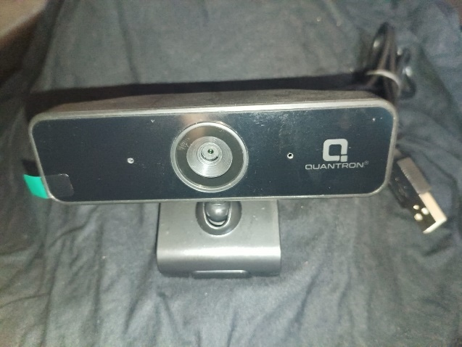

4.2 STANDARD RUBIK’S CUBE

A standard Rubik’s Cube measures 5.7 cm on each side and consists of 26 smaller cube pieces, also known as cubies or cubelets. These pieces are connected to a central core mechanism that allows rotation of each face while maintaining the cube’s structure.

The core contains three intersecting axes, holding the six fixed centerpieces—one per face—which do not move but rotate in place. The remaining pieces include edge pieces (with two colors) and corner pieces (with three colors). Together, these form the full 3×3×3 puzzle.

Each center is held in place by a spring-loaded screw, allowing for tension adjustment. However, newer official models use rivets, making them non-adjustable.

The cube can be easily disassembled by rotating a face 45° and removing an edge piece, which can be useful for maintenance or manual resetting.

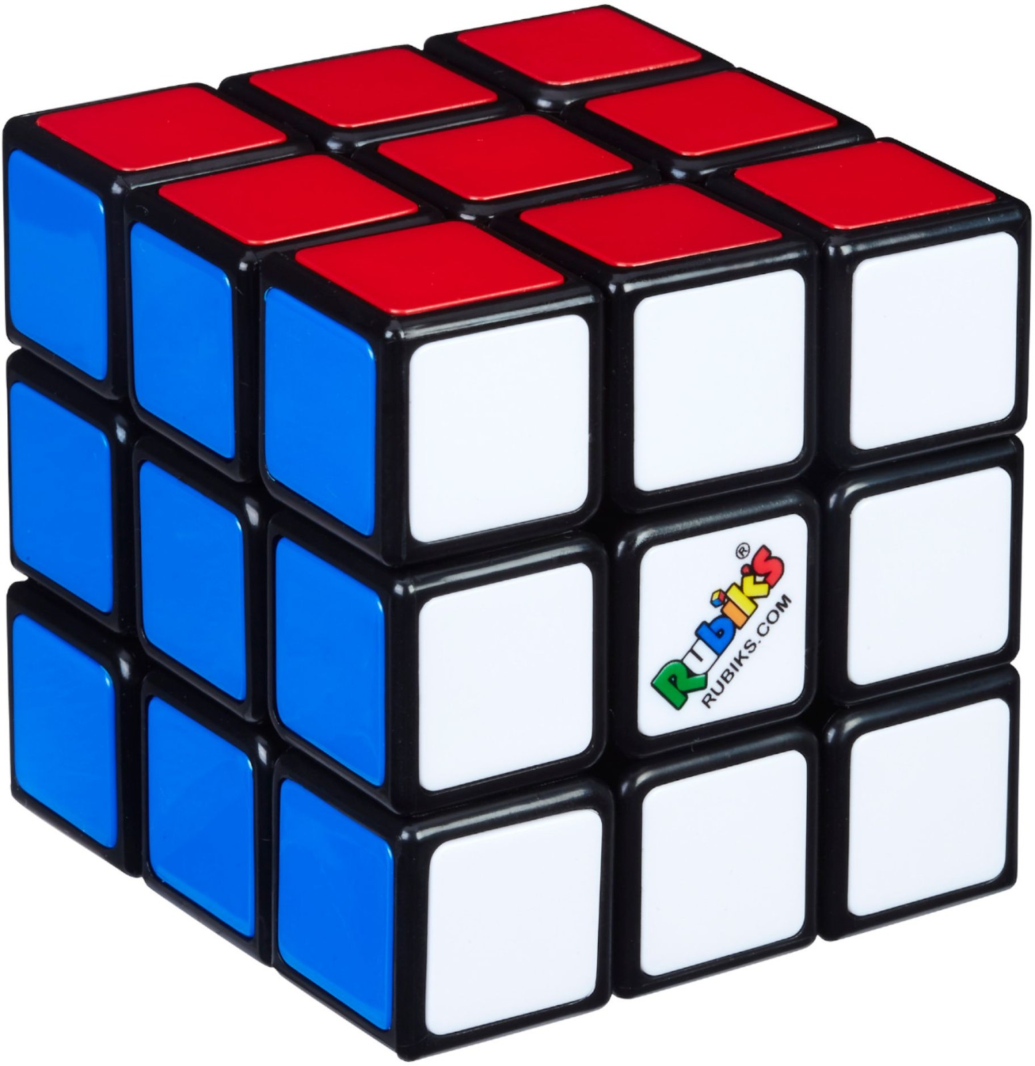

Figure 4.2 standard Rubik’s Cube.

CHAPTER 5
SYSTEM DESIGN

  - SYSTEM ARCHITECTURE
System architecture refers to the high-level design and structure of an application or system. It defines how components interact to meet both technical and operational requirements, while also addressing key quality attributes such as performance, scalability, maintainability, and security.
In our project, the architecture integrates image acquisition, color detection, solution generation using Kociemba’s Algorithm, and execution logic for move optimization. Although hardware components like servo motors are not implemented, the architecture is modular and designed for easy integration with robotic hardware in the future.

Figure 5.1 System architecture.
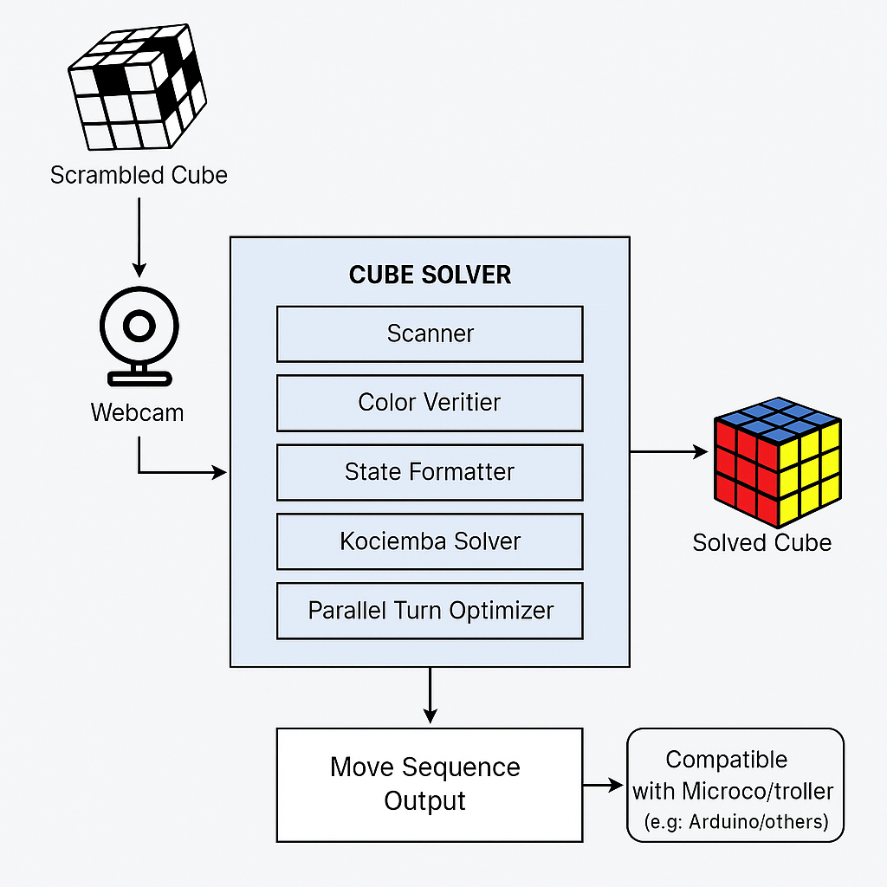

Explanation of System Architecture:
- Webcam captures images of the scrambled Rubik’s Cube.
- OpenCV (Scanner) detects the colors on all six faces.
- Color Verifier checks if all colors are valid and complete.
- State Formatter converts color data into a format the solver can understand.
- Kociemba Solver calculates the optimal solution (around 20 moves).
- Parallel Turn Optimizer finds moves that can be done at the same time to reduce solving time.
- Move Sequence Output provides the final step-by-step solution, ready for use with robotic systems.

5.2 USE CASE DIAGRAM
A Use Case Diagram is a dynamic or behavioral diagram in UML (Unified Modeling Language) that models the functionality of a system using actors and use cases. Use cases represent the actions, services, or functions the system must perform, while actors represent users or external systems that interact with the system.
Use case diagrams provide a high-level overview of system behavior and help in:
- Understanding functional requirements
- Identifying external/internal influences
- Supporting design decisions and development priorities
- Showing interactions between users and the system without diving into implementation details

System Use Case – Rubik’s Cube Solver
In our project, the Rubik’s Cube Solver software follows this sequence:
- The user (actor) places a scrambled Rubik’s Cube in front of a webcam.
- The system scans all six faces of the cube.
- The captured color data is stored in a Pattern Database.
- The system verifies the data to ensure all colors and positions are valid.
- If valid, the system uses Kociemba’s Algorithm to generate a solution.
- (Optional for future work) This solution can be sent to Arduino and servo motors to perform physical moves.
- The system displays or outputs the sequence of moves to solve the cube.

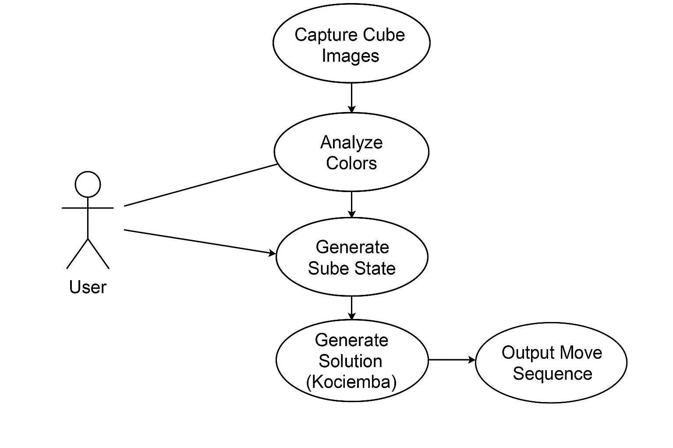

Figure 5.2 Use Case Diagram

5.3 CLASS DIAGRAM
In software engineering, a Class Diagram is a type of static structure diagram in UML (Unified Modeling Language) that represents the structure of a system. It illustrates the system's classes, their attributes, methods, and the relationships between them.
Class diagrams are essential in object-oriented modeling, serving both for:
- High-level design and conceptual understanding of the application
- Detailed modeling that directly translates into programming code
They also help in data modeling and identifying how components in the system will interact.
In our Rubik’s Cube Solver project, the class diagram includes key components such as:
- Scanner – captures image data
- ColorDetector – identifies colors from the scanned input
- StateFormatter – converts color data into cube notation
- Solver – uses Kociemba’s algorithm to compute the solution
- Optimizer – identifies and applies parallel turns
- MoveOutput – handles the final sequence output
These classes work together to form the software logic of the cube-solving system.

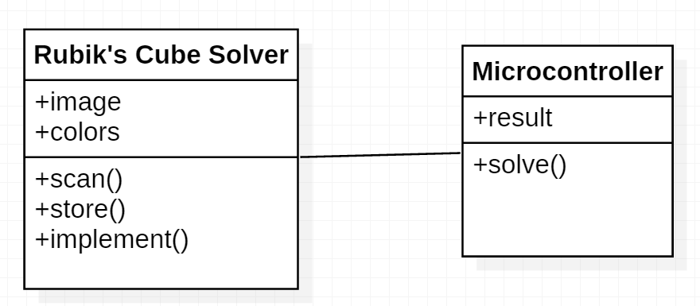
Figure 5.3 class diagram for the proposed system.

CHAPTER 6:
SYSTEM IMPLEMENTATION
6.1 TERMINOLOGIES
This section explains the key terminologies used in the project. The two primary terms are:
- Pattern Database
- Turns and Notations
6.1.1 PATTERN DATABASE
In this project, the scrambled state of the Rubik’s Cube is represented and stored in a structured table format. A standard Rubik’s Cube consists of 6 faces, each with 9 squares, resulting in a total of 54 individual squares.
To solve the cube computationally, the color or position of each of these 54 squares must be recorded and mapped. This collection of data is stored in what is known as the Pattern Database.
Figure 6.1 Pattern Database
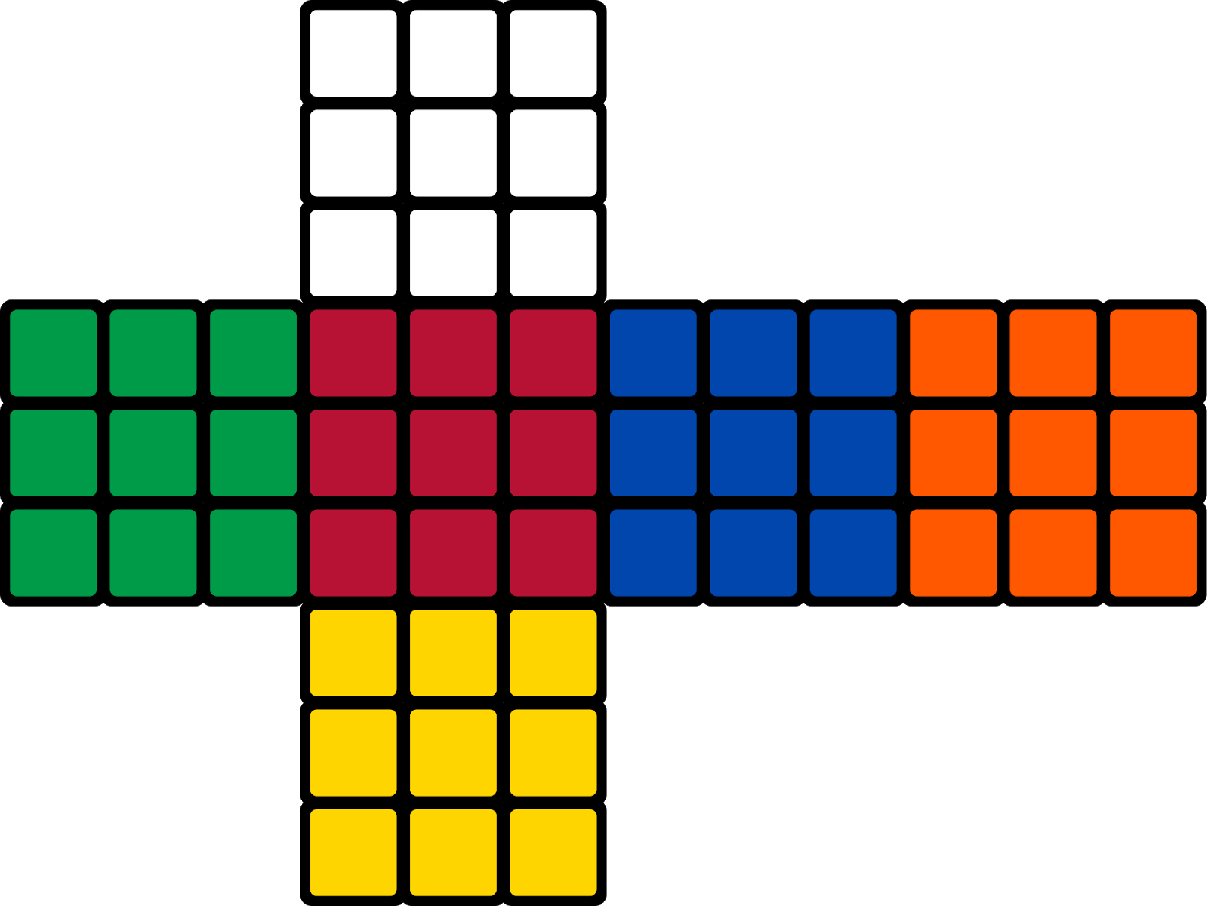

6.1.2 TURNS AND IT’S NOTATIONS

The various turns and their corresponding notation

Notation | Direction | Face
R | Clockwise | Right
L | Clockwise | Left
U | Clockwise | Up
D | Clockwise | Down
B | Clockwise | Back
F | Clockwise | Front
R’ | Anticlockwise | Right
L’ | Anticlockwise | Left
U’ | Anticlockwise | Up
D’ | Anticlockwise | Down
B’ | Anticlockwise | Bottom
F’ | Anticlockwise | Face
R2 | Double | Right
L2 | Double | Left
U2 | Double | Up
D2 | Double | Down
B2 | Double | Bottom
F2 | Double | Face

Table 6.1 List of Turns

6.2 MODULES
The system is divided into the following key modules, each responsible for a specific functionality in the cube-solving process:
- Image Processing & Colour Detection
- Finding the Solution using Kociemba’s Algorithm
- Optimizing the Solution by Marking Parallel Turns
- Solving the Cube

6.2.1 IMAGE PROCESSING & COLOUR DETECTION
Image processing is the technique of converting an image into a digital format and performing operations to extract meaningful information or enhance the image. In this project, image processing is used to detect and identify the colors on each face of the Rubik’s Cube.
The input to this module is a live image stream captured via a webcam, and the output is a mapped set of color values corresponding to the cube's stickers. This color data is essential for constructing the current cube state before solving.
The three key steps in image processing are:
- Image Acquisition: Capturing cube face images using a webcam.
- Image Analysis: Detecting and classifying colors using tools like OpenCV, and handling tasks such as filtering, enhancement, and pattern recognition.
- Output Generation: Producing structured color data that feeds into the next module—the solver.
This module is critical, as accurate color detection directly affects the quality of the cube's solution. Techniques from signal processing and computer vision are applied to ensure consistent and precise detection.

6.2.2 FINDING THE SOLUTION USING KOCIEMBA’S ALGORITHM
Kociemba’s Algorithm is a highly efficient method used to solve the Rubik’s Cube in two main phases. It reduces the problem by dividing the solution process into manageable steps, leading to an optimized sequence of moves—typically fewer than 20.

6.2.2.1 TWO-PHASE METHOD
The Two-Phase method works as follows:
- Phase 1:
Reduce the cube to a simplified form (known as G1) where all edge and corner orientations are correct and middle layer edges are in place.
- Phase 2:
Solve the cube from the G1 state using only a limited set of moves: <U, D, F2, B2, R2, L2>.
Iterative Deepening is used in Phase 1 to explore all possible move sequences up to a maximum depth, trying to find the shortest total solution. It progressively tests longer combinations only when shorter ones don’t lead to a complete solution. This ensures efficiency and helps find an optimal or near-optimal solution.

6.2.2.2 DOMINO PHASE
In this phase, the cube is in a special subgroup known as G1, which has the following properties:
- All edges and corners are oriented
- All middle layer edges are in the correct layer
From here, the cube behaves like a Domino Puzzle, allowing only double-layer turns (F2, B2, R2, L2, U, D). This restriction dramatically reduces the complexity of solving the cube from this state.
Advantages of the Domino Phase:
- The search space becomes smaller and more symmetrical.
- Efficient pruning using lookup/prune tables speeds up the solution.
- The method supports the use of IDA* (Iterative Deepening A*), which uses heuristics to find optimal paths faster.
Even though G1 is as complex to reach as solving the rest of the cube, the symmetry and efficiency of the search in the domino phase make Kociemba’s approach one of the best methods for cube-solving software.

6.2.3 OPTIMIZING THE SOLUTION BY MARKING PARALLEL TURNS
Although the solution generated by Kociemba’s Algorithm is already optimized in terms of move count, further optimization can be achieved by identifying and executing parallel turns.
Parallel turns refer to moves that involve opposite faces of the Rubik’s Cube (e.g., U and D, L and R, F and B) that do not interfere with each other and can be performed simultaneously. By detecting such cases in the move sequence and executing them in parallel, the total time required to solve the cube can be significantly reduced—even if the number of moves remains the same.
This step focuses on time optimization rather than move count reduction.

6.2.4 SOLVING THE CUBE
The final solution generated by the solver is a string of moves, such as "U R U' L2 D B'...". Each move in the string corresponds to a rotation of a face on the Rubik’s Cube.
In a typical hardware implementation (e.g., using Arduino), the steps are:
- The solution string is sent to the microcontroller.
- The string is split into individual moves and stored in an array.
- Each move is mapped to a specific servo motor action.
- The microcontroller controls the servo motors to perform the face rotations on the cube, solving it step by step.
Note: In our current project, hardware execution is not implemented, but the solution string is fully compatible with such robotic systems for future extension.
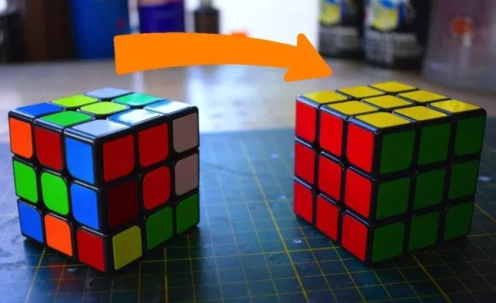
Figure 6.2 Before and after solve

CHAPTER 7
CONCLUSION
7.1 CONCLUSION
This project explored the presence and impact of parallel turns in Rubik’s Cube solutions. Based on the analysis of 100 scrambles, it was observed that approximately 80 scrambles contained parallel turns, resulting in a probability of 0.8 for their occurrence. On average, 2 to 3 parallel turns were found per scramble.
The system developed in this project not only provides an optimal solution using Kociemba’s Algorithm, but also introduces a novel optimization technique that marks and groups parallel moves, allowing them to be executed simultaneously. This technique can be implemented in any Rubik’s Cube-solving robot to improve execution speed without changing the move count.
Consider a robot that solves a Rubik’s Cube in 1 second, executing each move in 50 milliseconds (1/20 seconds). If two moves in the solution are parallel and can be performed together, the solving time can be reduced as follows:
- Old Time: 1.00 second
- Time Saved: 2 × 0.05 = 0.10 seconds
- New Time: 1.00 − 0.10 = 0.90 seconds
This results in a 10% reduction in solving time, without modifying the algorithm or the number of moves—simply by optimizing the execution strategy.
Percentage of time preserved:
(1 − 0.9)/1 * 100 % = 10%
This proves that the concept of parallel turn optimization can make high-speed cube-solving robots even faster, making this project a valuable step toward improving robotic efficiency in solving twisty puzzles.

7.2 Future Enhancement
In the current setup, a single webcam is used to scan all six faces of the Rubik’s Cube manually, which involves significant physical effort. Future improvements could include using multiple cameras or a rotating mechanism to automate scanning.
Accurate color detection also depends on good camera quality and proper lighting. Using a high-resolution camera and controlled lighting setup would enhance detection accuracy.
Additionally, the solution string from the solver is manually fed into the Arduino, and compiling the Arduino code takes over 5 seconds. These steps can be optimized by enabling direct communication between the software and hardware and considering faster microcontroller options.
These enhancements would make the system more efficient, faster, and fully automated.

APPENDIX 1

SAMPLE CODING

vision.py

#WEBCAM

import cv2

import numpy as np import vision_params grid_N = 25

def drawgrid(img, n): h, w = img.shape[:2] sz = h // n

border = 1 * sz

APPENDIX 1 SAMPLE CODING

for y in range(border, h - border, sz):

for x in range(border, w - border, sz): cv2.rectangle(img, (x, y), (x + sz, y + sz), (0, 0, 0), 1)

cv2.rectangle(img, (x - 1, y - 1), (x + 1 + sz, y + 1 + sz), (255, 255, 255), 1)

def del_duplicates(pts): delta = width / 12 dele = True

while dele: dele = False

r = range(len(pts))

for i in r:

for j in r[i + 1:]:

if np.linalg.norm(pts[i] - pts[j]) < delta:

del pts[j] dele = True

if dele:

break if dele:

break def medoid(pts):

res = np.array([0.0, 0.0]) smin = 100000

for i in pts: s = 0

for j in pts:

s += np.linalg.norm(i - j)

if s < smin: smin = s res = i

return res

def facelets(pts, med): ed = []

co = []

if med[0] == 0:

return co, ed dmin = 10000 for p in pts:

d = np.linalg.norm(p - med)

if 1 < d < dmin:

dmin = d

for p in pts:

d = np.linalg.norm(p - med)

if dmin - 1 < d < dmin * 1.3: ed.append(p)

for p in pts:

d = np.linalg.norm(p - med)

if dmin * 1.3 < d < dmin * 1.7: co.append(p)

return co, ed

def mirr_facelet(co, ed, med): aef = []

acf = []

for p in ed:

pa = 2 * med - p aef.append(pa)

for p in co:

pa = 2 * med - p acf.append(pa)

delta = width / 12

for k in range(len(aef) - 1, -1, -1):

for p in ed:

if np.linalg.norm(aef[k] - p) < delta:

del aef[k]

break

for k in range(len(acf) - 1, -1, -1):

for p in co:

if np.linalg.norm(acf[k] - p) < delta:

del acf[k]

break return acf, aef

def display_colorname(bgrcap, p): p = p.astype(np.uint16)

_, col = getcolor(p)

if col in ('blue', 'green', 'red'): txtcol = (255, 255, 255)

else:

txtcol = (0, 0, 0)

font = cv2.FONT_HERSHEY_SIMPLEX

tz = cv2.getTextSize(col, font, 0.4, 1)[0] cv2.putText(

bgrcap, col, tuple(p - (tz[0] // 2, -tz[1] // 2)), font, 0.4, txtcol, )

def getcolor(p): sz = 10

p = p.astype(np.uint16)

rect = hsv[p[1] - sz:p[1] + sz, p[0] - sz:p[0] + sz] median = np.sum(rect, axis=(0, 1)) / sz / sz / 4 mh, ms, mv = median

if ms <= vision_params.sat_W and mv >= vision_params.val_W:

return median, 'white'

elif vision_params.orange_L <= mh < vision_params.orange_H:

return median, 'orange'

elif vision_params.orange_H <= mh < vision_params.yellow_H:

return median, 'yellow'

elif vision_params.yellow_H <= mh < vision_params.green_H:

return median, 'green'

elif vision_params.green_H <= mh < vision_params.blue_H:

return median, 'blue' else:

return median, 'red'

def getcolors(co, ed, aco, aed, m):

centers = [[m for x in range(3)] for x in range(3)] colors = [['' for x in range(3)] for x in range(3)] s = np.array([0., 0., 0.])

hsvs = [[s for x in range(3)] for x in range(3)] cocents = co +aco

if len(cocents) != 4:

return [], [] edcents = ed + aed if len(edcents) != 4:

return [], []

for i in cocents:

if i[0] < m[0] and i[1] < m[1]: centers[0][0] = i

elif i[0] > m[0] and i[1] < m[1]: centers[0][2] = i

elif i[0] < m[0] and i[1] > m[1]: centers[2][0] = i

elif i[0] > m[0] and i[1] > m[1]: centers[2][2] = i

for i in edcents:

if i[1] < centers[0][1][1]: centers[0][1] = i

for i in edcents:

if i[0] < centers[1][0][0]: centers[1][0] = i

for i in edcents:

if i[0] > centers[1][2][0]: centers[1][2] = i

for i in edcents:

if i[1] > centers[2][1][1]: centers[2][1] = i

for x in range(3):

for y in range(3):

hsv_, col = getcolor(centers[x][y]) colors[x][y] = col

hsvs[x][y] = hsv_

return hsvs, colors

def find_squares(bgrcap, n):

global mask, color_mask, white_mask, black_mask h, s, v = cv2.split(hsv)

h_sqr = np.square(h) sz = height // n border = 1 * sz

varmax_edges = 20

for y in range(border, height - border, sz):

for x in range(border, width - border, sz): rect_h = h[y:y + sz, x:x + sz] rect_h_sqr = h_sqr[y:y + sz, x:x + sz] median_h = np.sum(rect_h) / sz / sz sqr_median_h = median_h * median_h

median_h_sqr = np.sum(rect_h_sqr) / sz / sz var = median_h_sqr - sqr_median_h

sigma = np.sqrt(var)

delta = vision_params.delta_C

if sigma < vision_params.sigma_W:

rect3x3 = hsv[y - 1 * sz:y + 2 * sz, x - 1 * sz:x + 2 * sz] mask = cv2.inRange(rect3x3, (0, 0, vision_params.val_W),

(255, vision_params.sat_W, 255)) white_mask[y - 1 * sz:y + 2 * sz, x - 1 * sz:x + 2 * sz] = \

cv2.bitwise_or(mask, white_mask[y - 1 * sz:y + 2 * sz, x - 1

* sz:x + 2 * sz])

if sigma < vision_params.sigma_C:

rect3x3 = h[y - 1 * sz:y + 2 * sz, x - 1 * sz:x + 2 * sz]

if median_h + delta >= 180:

mask = cv2.inRange(rect3x3, 0, median_h + delta - 180) mask = cv2.bitwise_or(mask, cv2.inRange(rect3x3,

median_h - delta, 180))

elif median_h - delta < 0:

mask = cv2.inRange(rect3x3, median_h - delta + 180, 180)

mask = cv2.bitwise_or(mask, cv2.inRange(rect3x3, 0, median_h + delta))

else:

mask = cv2.inRange(rect3x3, median_h - delta, median_h+ delta)

color_mask[y - 1 * sz:y + 2 * sz, x - 1 * sz:x + 2 * sz] = \ cv2.bitwise_or(mask, color_mask[y - 1 * sz:y + 2 * sz, x -1 * sz:x + 2 * sz])

black_mask = cv2.inRange(bgrcap, (0, 0, 0), (vision_params.rgb_L, vision_params.rgb_L, vision_params.rgb_L))

black_mask = cv2.bitwise_not(black_mask)

color_mask = cv2.bitwise_and(color_mask, black_mask) color_mask = cv2.blur(color_mask, (20, 20))

color_mask = cv2.inRange(color_mask, 240, 255) white_mask = cv2.bitwise_and(white_mask, black_mask) white_mask = cv2.blur(white_mask, (20, 20))

white_mask = cv2.inRange(white_mask, 240, 255) itr = iter([white_mask, color_mask])

for j in itr:

contours, hierarchy = cv2.findContours(j, cv2.RETR_EXTERNAL, cv2.CHAIN_APPROX_SIMPLE)

for n in range(len(contours)):

approx = cv2.approxPolyDP(contours[n], sz // 2, True) if approx.shape[0] != 4:

continue

corners = approx[:, 0]

edges = np.array([cv2.norm(corners[0] - corners[1], cv2.NORM_L2), cv2.norm(corners[1] - corners[2], cv2.NORM_L2),

cv2.norm(corners[2] - corners[3], cv2.NORM_L2), cv2.norm(corners[3] - corners[0], cv2.NORM_L2)])

edges_mean_sq = (np.sum(edges) / 4) ** 2 edges_sq_mean = np.sum(np.square(edges)) / 4

if edges_sq_mean - edges_mean_sq > varmax_edges:

continue

middle = np.sum(corners, axis=0) / 4 cent.append(np.asarray(middle))

def grab_colors():

global cent, width, height, hsv, color_mask, white_mask cap = cv2.VideoCapture(0)

bgrcap = cap.read()

if bgrcap is None:

print('Cannot connect to webcam!') return

height, width = bgrcap.shape[:2]

while 1:

bgrcap = cap.read()

bgrcap = cv2.blur(bgrcap, (5, 5))

hsv = cv2.cvtColor(bgrcap, cv2.COLOR_BGR2HSV) h, s, v = cv2.split(hsv)

h_mask = cv2.inRange(h, 0, 160)

h = cv2.bitwise_and(h, h, mask=h_mask)

hsv = cv2.merge((h, s, v)).astype(float)

color_mask = cv2.inRange(bgrcap, np.array([1, 1, 1]), np.array([0, 0, 0]))

white_mask = cv2.inRange(bgrcap, np.array([1, 1, 1]), np.array([0, 0, 0]))

cent = [] find_squares(bgrcap, grid_N) del_duplicates(cent)

m = medoid(cent)

cf, ef = facelets(cent, m)

acf, aef = mirr_facelet(cf, ef, m) display_colorname(bgrcap, m) for i in ef:

display_colorname(bgrcap, i)

for i in cf: display_colorname(bgrcap, i)

for i in aef: display_colorname(bgrcap, i)

for i in acf: display_colorname(bgrcap, i)

vision_params.face_hsv, vision_params.face_col = getcolors(cf, ef, acf, aef, m)

k = cv2.waitKey(5) & 0xFF

if k == 120:

break

cv2.destroyAllWindows()

APPENDIX 2

SCREENSHOTS
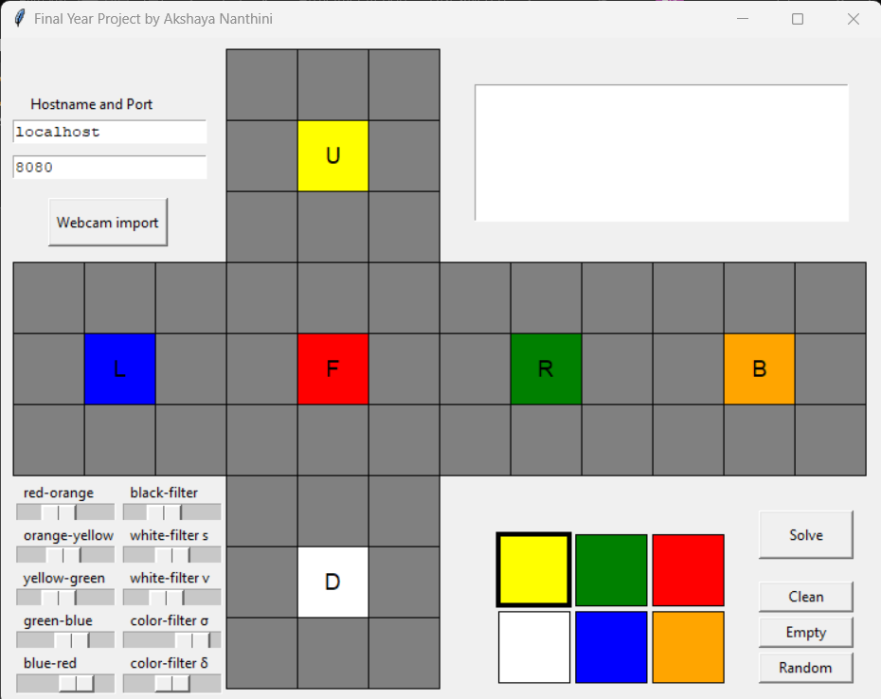

Figure 8.1: Before Scanning Cube Solver

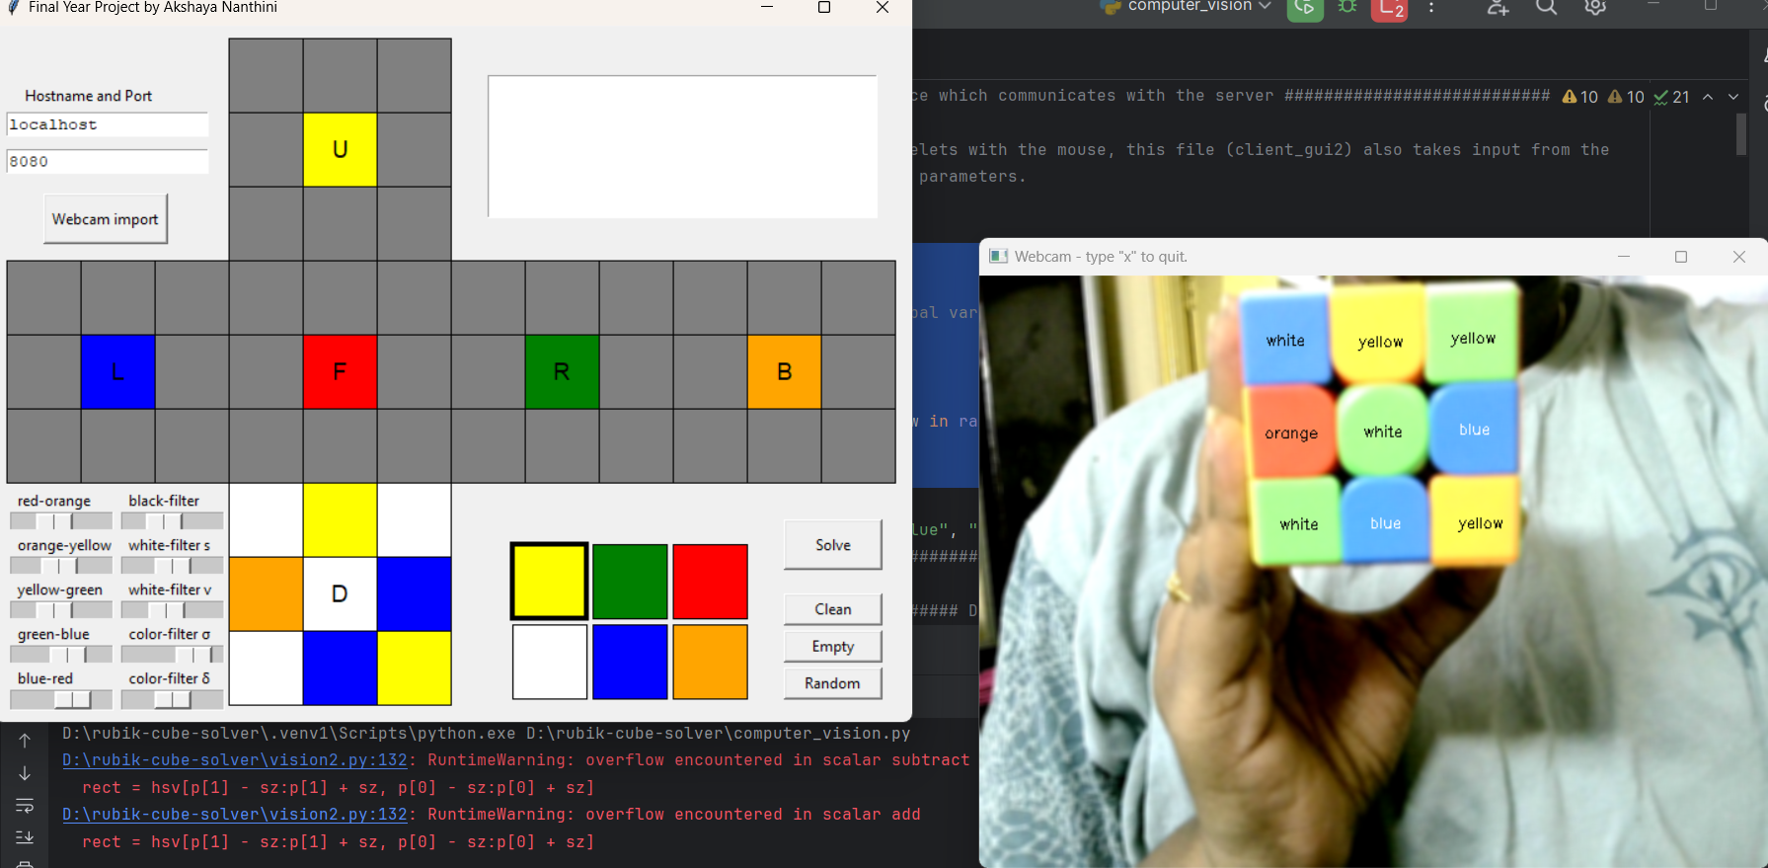

Figure 8.2: While scanning Cube Solver

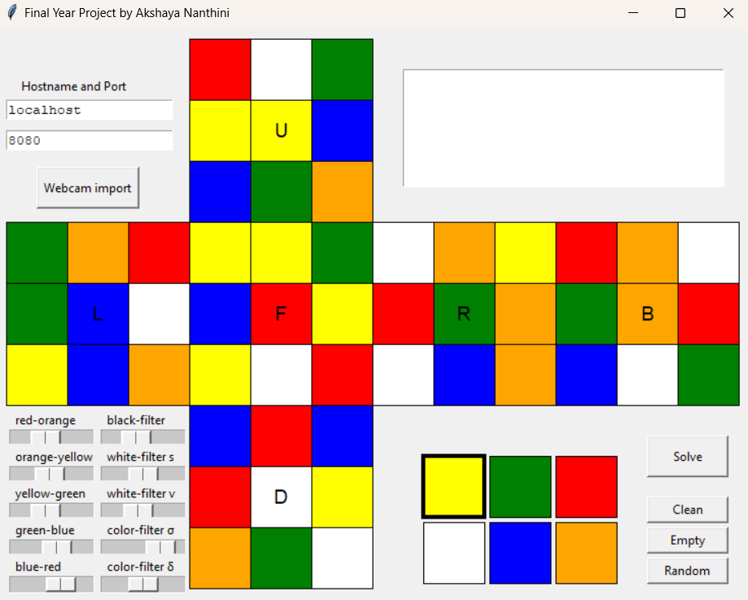

Figure 8.3: After Scanning Cube Solver

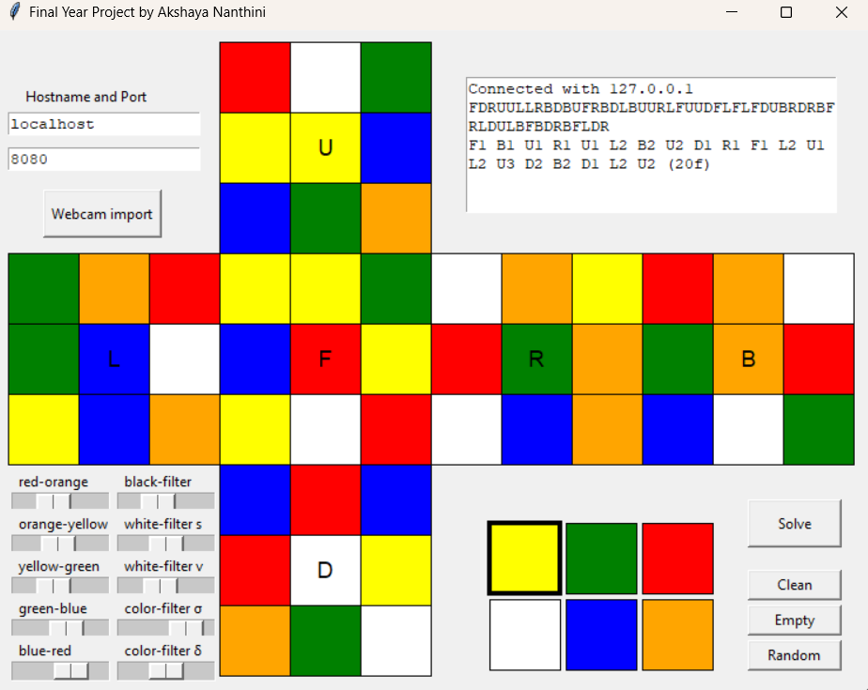

Figure 8.4: After Finding a Solution Cube Solver

REFERENCES

- S. A. Hutchinson, G. D. Hager, and P. I. Corke. A tutorial on visual servo control. IEEE Trans. on Robotics and Automation, 12(5):651–670, Oct 1996.

- R. Korf. Finding optimal solutions to rubik’s cube using pattern databases. In Proceedings of the National Conference on Artificial Intelligence (AAAI-97), pages 700–705. July 1997

- Culberson, J., and J. Schaeffer. Pattern Databases, Computational Intelligence, Vol. 14, No. 3, 1998, pp. 318–334.

- Edelkamp, S. and R.E. Korf, The branching factor of regular search spaces, Proceedings of the National Conference on Artificial Intelligence (AAAI-98), Madison, WI, July, 1998, pp. 299–304.

- Daniel Truesdell and Corey Holsey Rubik’s Cube Solving Robot by EEL4914—Spring 2016 Group 12

- Harshad Sawhney, Sakshi Sinha, Anurag Lohia, Prashant Jalan Autonomous Rubik's Cube Solver Using Image Processing International Journal of Engineering Research & Technology (IJERT) ISSN: 2278-0181 Vol. 2 Issue 10, October – 2013

- C Bandelow. Inside Rubik’S Cube and Beyond. Boston: Publisher Birkhauser Boston Inc., 1980.

- J M Wang, J P Fang, N Zhang. The application of combination creation in the shape design of the Rubik’s Cubic. Art Panorama. 2013(6): 105–105. (in Chinese)

- Luis Barba-Guamán, Carlos Calderon-Cordova, Pablo Alejandro Quezada-Sarmiento Detection of moving objects through color thresholding 2017 12th Iberian Conference on Information Systems and Technologies (CISTI) 10.23919/CISTI.2017.7975755

- Munadi ; M. Amirullah Akbar Simulation of fuzzy logic control for DC servo motor using Arduino based on MATLAB/Simulink 2014 International Conference on Intelligent Autonomous Agents, Networks and Systems 10.1109/ INAGENTSYS. 2014.7005723

- C. Urrea and J Kern, "A New Model for Analog Servo Motors", Canadian Journal on Automation, Control and Intelligent Systems, Vol. 2, No. 2, March 2011.

